Picture Refences

All pictures from the original Duquesne Incline website except the following which are from Wiki creative commons used on Wikipedia Duquesne Commons wiki entry.

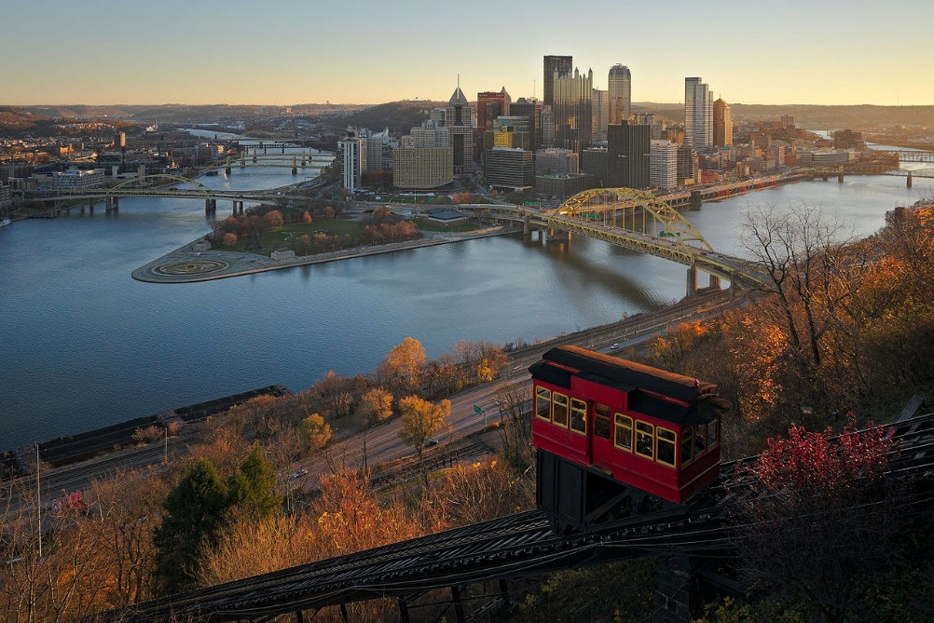

[Dllu](https://commons.wikimedia.org/wiki/User:Dllu) - Own work

* [CC BY-SA 4.0](https://creativecommons.org/licenses/by-sa/4.0)
* File:Downtown Pittsburgh from Duquesne Incline in the morning.jpg
* Created: 20 November 2015
* [Location: 40° 26′ 18.24″ N, 80° 1′ 8.17″ W](https://tools.wmflabs.org/geohack/geohack.php?pagename=File:Downtown_Pittsburgh_from_Duquesne_Incline_in_the_morning.jpg&params=40.438401_N_80.018936_W_&language=en)

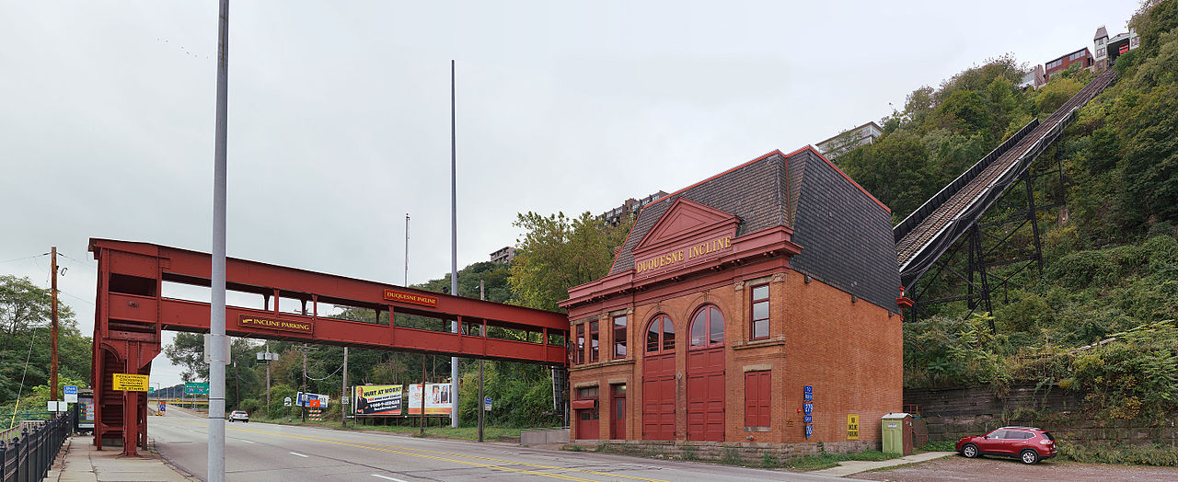

[Dllu](https://commons.wikimedia.org/wiki/User:Dllu) - Own work

The lower station of the [Duquesne Incline](https://en.wikipedia.org/wiki/Duquesne_Incline), a funicular in [Pittsburgh](https://en.wikipedia.org/wiki/Pittsbugh). This is a panorama using a rectilinear projection.

* [CC BY-SA 4.0](https://creativecommons.org/licenses/by-sa/4.0)
* File:Duquesne Incline lower station.jpg
* Created: 4 October 2015
* [Location: 40° 26′ 24.07″ N, 80° 1′ 3.19″ W](https://tools.wmflabs.org/geohack/geohack.php?pagename=File:Duquesne_Incline_lower_station.jpg&params=40.440019_N_80.017554_W_&language=en)

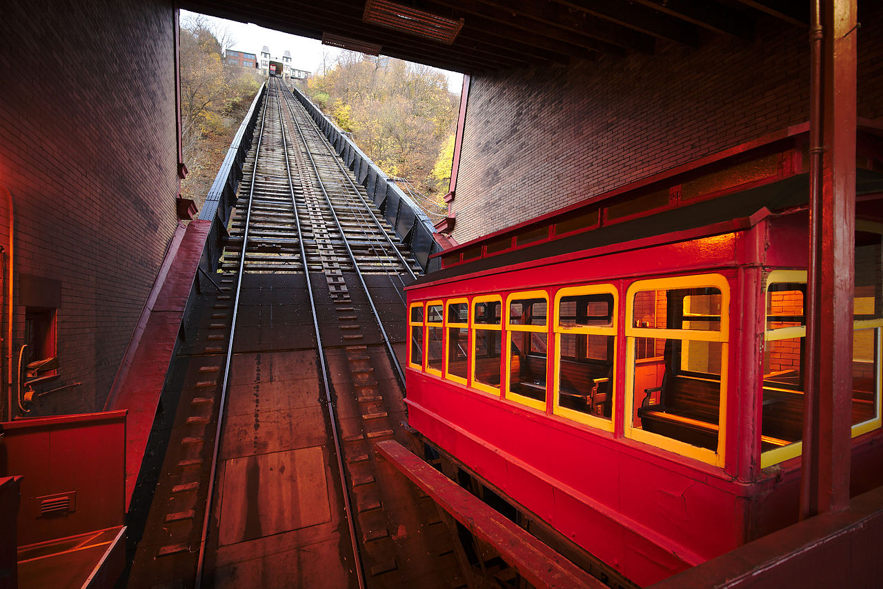

[Dllu](https://commons.wikimedia.org/wiki/User:Dllu) - Own work

Inside the lower station of the [Duquesne incline](https://en.wikipedia.org/wiki/Duquesne_Incline), one of two surviving inclines in [Pittsburgh](https://en.wikipedia.org/wiki/Pittsburgh).

* [CC BY-SA 4.0](https://creativecommons.org/licenses/by-sa/4.0)
* File:Duquesne Incline lower station with incline car.jpg
* Created: 20 November 2015
* [Location: 40° 26′ 23.49″ N, 80° 1′ 3.33″ W](https://tools.wmflabs.org/geohack/geohack.php?pagename=File:Duquesne_Incline_lower_station_with_incline_car.jpg&params=40.439857_N_80.017592_W_&language=en)

[About this interface](https://mediawiki.org/wiki/Special:MyLanguage/Extension:Media_Viewer/About) | [Discussion](https://mediawiki.org/wiki/Special:MyLanguage/Extension_talk:Media_Viewer/About) | [Help](https://mediawiki.org/wiki/Special:MyLanguage/Help:Extension:Media_Viewer)